SUMMARY

1. Redo Log size needs to be set to 5GB per redo log.
- In average, environment is having 60 switches per hour, where the optimal value is 4 to 6 per hour
- To reach the size for redos, we can use the formula below:
(Current Switches per hour * Redo Log Size)/(Desired number of Switches)=New redo log size
- As identified, current log switch is close 60 switches per hour (page 3, Redo log generation per day)
- Current log size is 500mb (Page 14, Current Redo Size)
- Targeting 3 switches per hour, based on the current scenario:
(60*500MB)/3 = 10000 : 10GB approx.
- We can move this incrementally as this can have an impact on standby as well, starting with 5Gb
- We expect 6-8 switches per hour after redo change.
2. Large_Pool_Size
- This will pre-allocate a MINIMUM size for LARGE_POOL_SIZE
- 5% of SGA
- If SGA_TARGET is set, but a value is not specified for LARGE_POOL_SIZE, then the default is 0 (internally determined by the Oracle database). If LARGE_POOL_SIZE is specified, then the user-specified value indicates a minimum value for the memory pool.
- The large pool allocation heap is used in shared server systems for session memory, by parallel execution for message buffers, and by backup processes for disk I/O buffers. Parallel execution allocates buffers out of the large pool only when SGA_TARGET is set.

3. Gather Status
- Last successful run of the following job BEFORE changes:
- Gather Schema Statistics : Gather Y - NO DATA. All the runtime data we have seen point to this having failed and not succeeded.

- Last successful run of the following job AFTER changes:
- Gather Schema Statistics : Gather Y - 14 hours approximately to complete.

- Case: 00352568.
- Engineer allocated: Bob Schreiber

4. Performance
- Since upgrade, multiple cases open for performance issues (page 19, Performance Cases):
- 00347713, 00348061,00348479,00350308,00351689,00352147,00352565,00352568,00352572
- Most of the cases propose to set OPTIMIZER_FEATURES_ENABLED=’11.2.0.4’.
- The performance on 11g was known and stable. From 12c onwards several new access paths were added, leading to performance issues due to behavior change.
- Several EBS modules in use were developed before these new features (2006, 2013), so this new featured could have negative impacts on older programs.
- Setting OPTIMIZER_FEATURES_ENABLED would allow the optimizer to behave as 11g while still using all the other features available on 19c.
- Use than SPA to gather the main queries from PROD and test them on UAT 19c with OPTIMIZER_FEATURES_ENABLED=’19.7.0.0’.
- SPA will produce a report showing which queries will have an execution plan change, for the better or for the worst. Having this would expedite any work over sql_ids.
- As currently some tuning was done, the reverse could be done using SPA. Collect main queries, set OPTIMIZER_FEATURES_ENABLED=’11.2.0.4’ on UAT and do the comparison.

Architecture

- 2 Node RAC, HP, Linux 7, 1000G RAM
- 2 sockets, 24 cores, 48 CPUS
- Data Guard YES
- grubby --default-kernel
/boot/vmlinuz-3.10.0-1160.90.1.el7.x86_64
[root@lxprdb01 ~]# dmidecode -s system-manufacturer
HPE
[root@lxprdb02 ~]# dmidecode -s system-manufacturer
HPE
Sizing
Redo log generation per day

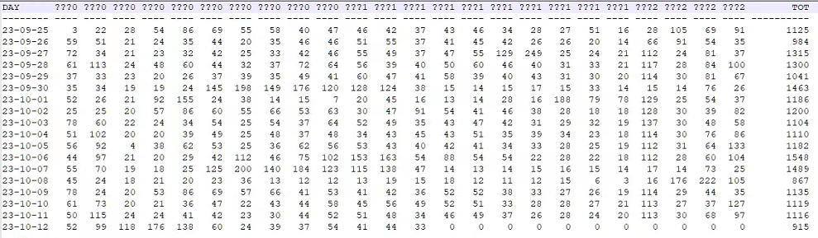
ASM disk groups, redundancy

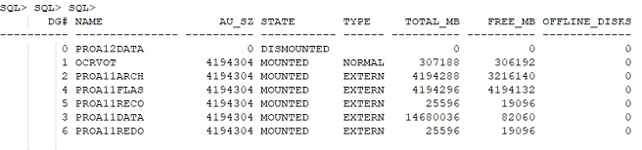
- No oracleasm/oracleafd

Configuration
Parameters
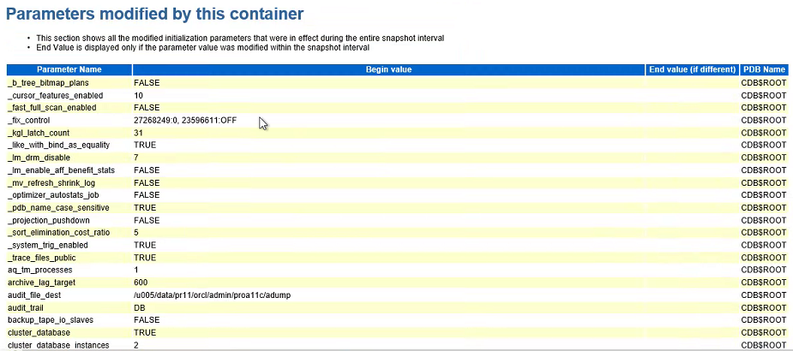
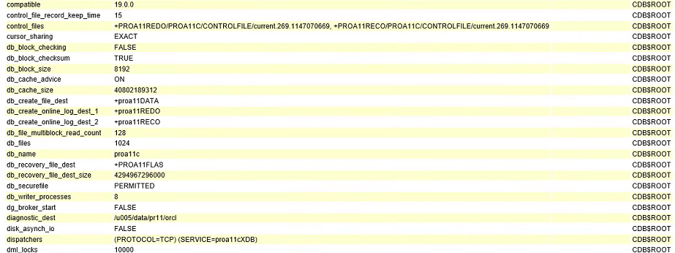
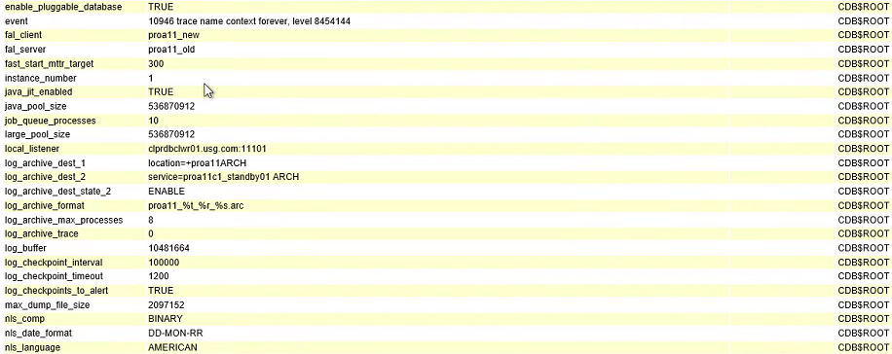
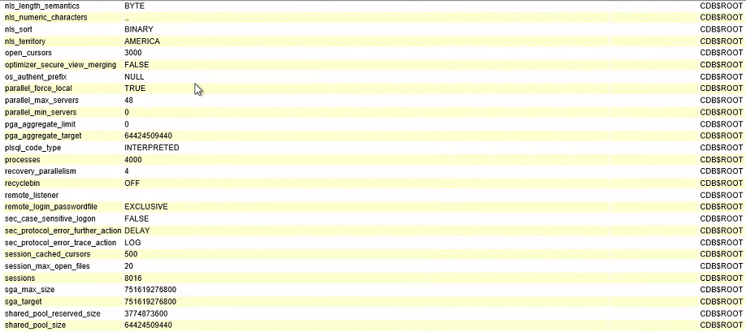
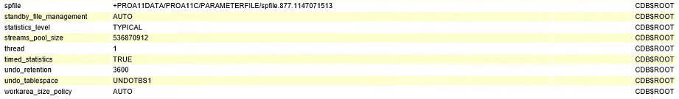
Kernel parameters
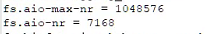
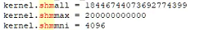

grep memlock /etc/security/limits.conf
# - memlock - max locked-in-memory address space (KB)
#* soft memlock 537934479
#* hard memlock 537934479
#* soft memlock 500000000
#* hard memlock 500000000
* soft memlock 750000000
* hard memlock 750000000
[orclpr11@lxprdb01 ~]$

orclpr11@lxprdb02 ~]$ grep memlock /etc/security/limits.conf
# - memlock - max locked-in-memory address space (KB)
#* soft memlock 400000000
#* hard memlock 400000000
#* soft memlock 500000000
#* hard memlock 500000000
* soft memlock 750000000
* hard memlock 750000000
[orclpr11@lxprdb02 ~]$
HugePages
[orclpr11@lxprdb01 ~]$ cat /sys/kernel/mm/transparent_hugepage/enabled
[always] madvise never

[orclpr11@lxprdb02 ~]$ cat /sys/kernel/mm/transparent_hugepage/enabled
[always] madvise never
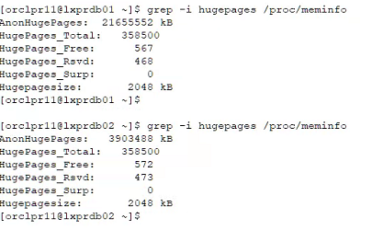

JumboPages

[orclglbl@lxprdb01 rules.d]$ oifcfg getif
bond0 10.50.201.0 global public
bond1 192.168.34.0 global cluster_interconnect,asm

[orclglbl@lxprdb02 ~]$ oifcfg getif
bond0 10.50.201.0 global public
bond1 192.168.34.0 global cluster_interconnect,asm

Interface information for node "lxprdb02"

Name IP Address Subnet Gateway Def. Gateway HW Address MTU
------ --------------- --------------- --------------- --------------- ----------------- ------
bond0 10.50.201.32 10.50.201.0 0.0.0.0 10.50.201.1 94:40:C9:FF:BD:98 1500
bond0 10.50.201.25 10.50.201.0 0.0.0.0 10.50.201.1 94:40:C9:FF:BD:98 1500
bond0 10.50.201.30 10.50.201.0 0.0.0.0 10.50.201.1 94:40:C9:FF:BD:98 1500
bond1 192.168.34.102 192.168.34.0 0.0.0.0 10.50.201.1 94:40:C9:FF:BD:9C 9000 << JBF

Interface information for node "lxprdb01"

Name IP Address Subnet Gateway Def. Gateway HW Address MTU
------ --------------- --------------- --------------- --------------- ----------------- ------
bond0 10.50.201.31 10.50.201.0 0.0.0.0 10.50.201.1 94:40:C9:FF:6D:80 1500
bond0 10.50.201.29 10.50.201.0 0.0.0.0 10.50.201.1 94:40:C9:FF:6D:80 1500
bond0 10.50.201.28 10.50.201.0 0.0.0.0 10.50.201.1 94:40:C9:FF:6D:80 1500
bond0 10.50.201.24 10.50.201.0 0.0.0.0 10.50.201.1 94:40:C9:FF:6D:80 1500
bond1 192.168.34.101 192.168.34.0 0.0.0.0 10.50.201.1 94:40:C9:FF:6D:84 9000 << JBF

[orclglbl@lxprdb01 rules.d]$ cat /proc/net/bonding/bond0
Ethernet Channel Bonding Driver: v3.7.1 (April 27, 2011)

Bonding Mode: IEEE 802.3ad Dynamic link aggregation
Transmit Hash Policy: layer2 (0)
MII Status: up
MII Polling Interval (ms): 100
Up Delay (ms): 0
Down Delay (ms): 0

802.3ad info
LACP rate: fast
Min links: 0
Aggregator selection policy (ad_select): bandwidth

Slave Interface: eno1
MII Status: up
Speed: 10000 Mbps
Duplex: full
Link Failure Count: 1
Permanent HW addr: 94:40:c9:ff:6d:80
Slave queue ID: 0
Aggregator ID: 2
Actor Churn State: none
Partner Churn State: none
Actor Churned Count: 0
Partner Churned Count: 0

Slave Interface: ens1f0
MII Status: up
Speed: 10000 Mbps
Duplex: full
Link Failure Count: 0
Permanent HW addr: 94:f1:28:b5:07:e2
Slave queue ID: 0
Aggregator ID: 2
Actor Churn State: none
Partner Churn State: none
Actor Churned Count: 0
Partner Churned Count: 0

Slave Interface: ens3f2
MII Status: up
Speed: 1000 Mbps
Duplex: full
Link Failure Count: 0
Permanent HW addr: 98:f2:b3:19:44:0e
Slave queue ID: 0
Aggregator ID: 3
Actor Churn State: churned
Partner Churn State: churned
Actor Churned Count: 1
Partner Churned Count: 1

Slave Interface: ens3f3
MII Status: up
Speed: 1000 Mbps
Duplex: full
Link Failure Count: 0
Permanent HW addr: 98:f2:b3:19:44:0f
Slave queue ID: 0
Aggregator ID: 4
Actor Churn State: churned
Partner Churn State: churned
Actor Churned Count: 1
Partner Churned Count: 1

[orclglbl@lxprdb02 ~]$ cat /proc/net/bonding/bond0
Ethernet Channel Bonding Driver: v3.7.1 (April 27, 2011)

Bonding Mode: IEEE 802.3ad Dynamic link aggregation
Transmit Hash Policy: layer2 (0)
MII Status: up
MII Polling Interval (ms): 100
Up Delay (ms): 0
Down Delay (ms): 0

802.3ad info
LACP rate: fast
Min links: 0
Aggregator selection policy (ad_select): bandwidth

Slave Interface: eno1
MII Status: up
Speed: 10000 Mbps
Duplex: full
Link Failure Count: 2
Permanent HW addr: 94:40:c9:ff:bd:98
Slave queue ID: 0
Aggregator ID: 2
Actor Churn State: none
Partner Churn State: none
Actor Churned Count: 0
Partner Churned Count: 0

Slave Interface: ens1f0
MII Status: up
Speed: 10000 Mbps
Duplex: full
Link Failure Count: 0
Permanent HW addr: 94:f1:28:b5:02:f6
Slave queue ID: 0
Aggregator ID: 2
Actor Churn State: none
Partner Churn State: none
Actor Churned Count: 0
Partner Churned Count: 0

Slave Interface: ens3f2
MII Status: up
Speed: 1000 Mbps
Duplex: full
Link Failure Count: 0
Permanent HW addr: 98:f2:b3:19:3f:16
Slave queue ID: 0
Aggregator ID: 3
Actor Churn State: churned
Partner Churn State: churned
Actor Churned Count: 1
Partner Churned Count: 1

Slave Interface: ens3f3
MII Status: up
Speed: 1000 Mbps
Duplex: full
Link Failure Count: 0
Permanent HW addr: 98:f2:b3:19:3f:17
Slave queue ID: 0
Aggregator ID: 4
Actor Churn State: churned
Partner Churn State: churned
Actor Churned Count: 1
Partner Churned Count: 1
[orclglbl@lxprdb02 ~]$
[orclglbl@lxprdb01 rules.d]$ cat /proc/net/bonding/bond1
Ethernet Channel Bonding Driver: v3.7.1 (April 27, 2011)

Bonding Mode: IEEE 802.3ad Dynamic link aggregation
Transmit Hash Policy: layer2 (0)
MII Status: up
MII Polling Interval (ms): 100
Up Delay (ms): 0
Down Delay (ms): 0

802.3ad info
LACP rate: fast
Min links: 0
Aggregator selection policy (ad_select): bandwidth

Slave Interface: eno2
MII Status: up
Speed: 10000 Mbps
Duplex: full
Link Failure Count: 1
Permanent HW addr: 94:40:c9:ff:6d:84
Slave queue ID: 0
Aggregator ID: 2
Actor Churn State: none
Partner Churn State: none
Actor Churned Count: 0
Partner Churned Count: 0

Slave Interface: ens1f1
MII Status: up
Speed: 10000 Mbps
Duplex: full
Link Failure Count: 0
Permanent HW addr: 94:f1:28:b5:07:e3
Slave queue ID: 0
Aggregator ID: 2
Actor Churn State: none
Partner Churn State: none
Actor Churned Count: 0
Partner Churned Count: 0

[orclglbl@lxprdb02 ~]$ cat /proc/net/bonding/bond1
Ethernet Channel Bonding Driver: v3.7.1 (April 27, 2011)

Bonding Mode: IEEE 802.3ad Dynamic link aggregation
Transmit Hash Policy: layer2 (0)
MII Status: up
MII Polling Interval (ms): 100
Up Delay (ms): 0
Down Delay (ms): 0

802.3ad info
LACP rate: fast
Min links: 0
Aggregator selection policy (ad_select): bandwidth

Slave Interface: eno2
MII Status: up
Speed: 10000 Mbps
Duplex: full
Link Failure Count: 2
Permanent HW addr: 94:40:c9:ff:bd:9c
Slave queue ID: 0
Aggregator ID: 2
Actor Churn State: none
Partner Churn State: none
Actor Churned Count: 0
Partner Churned Count: 0

Slave Interface: ens1f1
MII Status: up
Speed: 10000 Mbps
Duplex: full
Link Failure Count: 0
Permanent HW addr: 94:f1:28:b5:02:f7
Slave queue ID: 0
Aggregator ID: 2
Actor Churn State: none
Partner Churn State: none
Actor Churned Count: 0
Partner Churned Count: 0

ip link show
[orclglbl@lxprdb01 rules.d]$ ip link show
1: lo: <LOOPBACK,UP,LOWER_UP> mtu 65536 qdisc noqueue state UNKNOWN mode DEFAULT group default qlen 1000
link/loopback 00:00:00:00:00:00 brd 00:00:00:00:00:00
2: ens3f0: <BROADCAST,MULTICAST> mtu 1500 qdisc noop state DOWN mode DEFAULT group default qlen 1000
link/ether 98:f2:b3:19:44:0c brd ff:ff:ff:ff:ff:ff
3: ens3f1: <BROADCAST,MULTICAST> mtu 1500 qdisc noop state DOWN mode DEFAULT group default qlen 1000
link/ether 98:f2:b3:19:44:0d brd ff:ff:ff:ff:ff:ff
4: ens3f2: <BROADCAST,MULTICAST,SLAVE,UP,LOWER_UP> mtu 1500 qdisc mq master bond0 state UP mode DEFAULT group default qlen 1000
link/ether 94:40:c9:ff:6d:80 brd ff:ff:ff:ff:ff:ff
5: ens3f3: <BROADCAST,MULTICAST,SLAVE,UP,LOWER_UP> mtu 1500 qdisc mq master bond0 state UP mode DEFAULT group default qlen 1000
link/ether 94:40:c9:ff:6d:80 brd ff:ff:ff:ff:ff:ff
6: eno1: <BROADCAST,MULTICAST,SLAVE,UP,LOWER_UP> mtu 1500 qdisc mq master bond0 state UP mode DEFAULT group default qlen 1000
link/ether 94:40:c9:ff:6d:80 brd ff:ff:ff:ff:ff:ff
7: ens1f0: <BROADCAST,MULTICAST,SLAVE,UP,LOWER_UP> mtu 1500 qdisc mq master bond0 state UP mode DEFAULT group default qlen 1000
link/ether 94:40:c9:ff:6d:80 brd ff:ff:ff:ff:ff:ff
8: eno2: <BROADCAST,MULTICAST,SLAVE,UP,LOWER_UP> mtu 9000 qdisc mq master bond1 state UP mode DEFAULT group default qlen 1000
link/ether 94:40:c9:ff:6d:84 brd ff:ff:ff:ff:ff:ff
9: ens1f1: <BROADCAST,MULTICAST,SLAVE,UP,LOWER_UP> mtu 9000 qdisc mq master bond1 state UP mode DEFAULT group default qlen 1000
link/ether 94:40:c9:ff:6d:84 brd ff:ff:ff:ff:ff:ff
10: bond0: <BROADCAST,MULTICAST,MASTER,UP,LOWER_UP> mtu 1500 qdisc noqueue state UP mode DEFAULT group default qlen 1000
link/ether 94:40:c9:ff:6d:80 brd ff:ff:ff:ff:ff:ff
11: bond1: <BROADCAST,MULTICAST,MASTER,UP,LOWER_UP> mtu 9000 qdisc noqueue state UP mode DEFAULT group default qlen 1000
link/ether 94:40:c9:ff:6d:84 brd ff:ff:ff:ff:ff:ff
12: virbr0: <NO-CARRIER,BROADCAST,MULTICAST,UP> mtu 1500 qdisc noqueue state DOWN mode DEFAULT group default qlen 1000
link/ether 52:54:00:fc:f4:53 brd ff:ff:ff:ff:ff:ff
13: virbr0-nic: <BROADCAST,MULTICAST> mtu 1500 qdisc pfifo_fast master virbr0 state DOWN mode DEFAULT group default qlen 1000
link/ether 52:54:00:fc:f4:53 brd ff:ff:ff:ff:ff:ff
[orclglbl@lxprdb01 rules.d]$

[orclglbl@lxprdb02 ~]$ ip link show
1: lo: <LOOPBACK,UP,LOWER_UP> mtu 65536 qdisc noqueue state UNKNOWN mode DEFAULT group default qlen 1000
link/loopback 00:00:00:00:00:00 brd 00:00:00:00:00:00
2: ens3f0: <BROADCAST,MULTICAST> mtu 1500 qdisc noop state DOWN mode DEFAULT group default qlen 1000
link/ether 98:f2:b3:19:3f:14 brd ff:ff:ff:ff:ff:ff
3: ens3f1: <BROADCAST,MULTICAST> mtu 1500 qdisc noop state DOWN mode DEFAULT group default qlen 1000
link/ether 98:f2:b3:19:3f:15 brd ff:ff:ff:ff:ff:ff
4: ens3f2: <BROADCAST,MULTICAST,SLAVE,UP,LOWER_UP> mtu 1500 qdisc mq master bond0 state UP mode DEFAULT group default qlen 1000
link/ether 94:40:c9:ff:bd:98 brd ff:ff:ff:ff:ff:ff
5: ens3f3: <BROADCAST,MULTICAST,SLAVE,UP,LOWER_UP> mtu 1500 qdisc mq master bond0 state UP mode DEFAULT group default qlen 1000
link/ether 94:40:c9:ff:bd:98 brd ff:ff:ff:ff:ff:ff
6: eno1: <BROADCAST,MULTICAST,SLAVE,UP,LOWER_UP> mtu 1500 qdisc mq master bond0 state UP mode DEFAULT group default qlen 1000
link/ether 94:40:c9:ff:bd:98 brd ff:ff:ff:ff:ff:ff
7: ens1f0: <BROADCAST,MULTICAST,SLAVE,UP,LOWER_UP> mtu 1500 qdisc mq master bond0 state UP mode DEFAULT group default qlen 1000
link/ether 94:40:c9:ff:bd:98 brd ff:ff:ff:ff:ff:ff
8: ens1f1: <BROADCAST,MULTICAST,SLAVE,UP,LOWER_UP> mtu 9000 qdisc mq master bond1 state UP mode DEFAULT group default qlen 1000
link/ether 94:40:c9:ff:bd:9c brd ff:ff:ff:ff:ff:ff
9: eno2: <BROADCAST,MULTICAST,SLAVE,UP,LOWER_UP> mtu 9000 qdisc mq master bond1 state UP mode DEFAULT group default qlen 1000
link/ether 94:40:c9:ff:bd:9c brd ff:ff:ff:ff:ff:ff
10: bond0: <BROADCAST,MULTICAST,MASTER,UP,LOWER_UP> mtu 1500 qdisc noqueue state UP mode DEFAULT group default qlen 1000
link/ether 94:40:c9:ff:bd:98 brd ff:ff:ff:ff:ff:ff
11: bond1: <BROADCAST,MULTICAST,MASTER,UP,LOWER_UP> mtu 9000 qdisc noqueue state UP mode DEFAULT group default qlen 1000
link/ether 94:40:c9:ff:bd:9c brd ff:ff:ff:ff:ff:ff
12: virbr0: <NO-CARRIER,BROADCAST,MULTICAST,UP> mtu 1500 qdisc noqueue state DOWN mode DEFAULT group default qlen 1000
link/ether 52:54:00:ee:3b:1e brd ff:ff:ff:ff:ff:ff
13: virbr0-nic: <BROADCAST,MULTICAST> mtu 1500 qdisc pfifo_fast master virbr0 state DOWN mode DEFAULT group default qlen 1000
link/ether 52:54:00:ee:3b:1e brd ff:ff:ff:ff:ff:ff

BOND REVIEW:
Bond0 has 4 nic cards, but they have different speeds, two with 10000Mbs and two with 1000Mbs.
Some nic cards have link failure alert.
MTU for bond0 – public – is 1500, MTU for bond1 – interconnect – is 9000

Memory structures
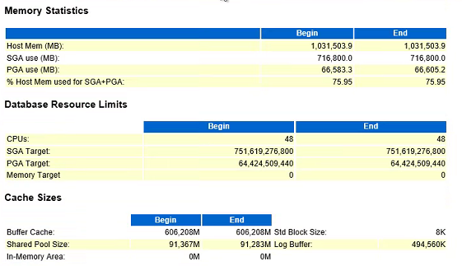
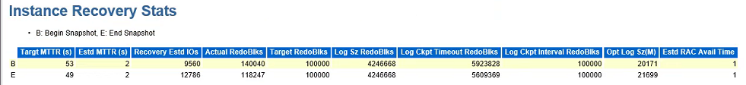

Current Redo Size
GROUP# THREAD# SEQUENCE# ARC STATUS REDOLOG_FILE_NAME SIZE_MB
---------- ---------- ---------- --- ---------------- ---------------------------------------------------- ----------
1 1 27366 YES INACTIVE +PROA11REDO/PROA11C/ONLINELOG/group_1.271.1147087221 512
1 1 27366 YES INACTIVE +PROA11RECO/PROA11C/ONLINELOG/group_1.270.1147087221 512
2 1 27367 YES INACTIVE +PROA11REDO/PROA11C/ONLINELOG/group_2.270.1147087253 512
2 1 27367 YES INACTIVE +PROA11RECO/PROA11C/ONLINELOG/group_2.271.1147087253 512
3 1 27368 YES INACTIVE +PROA11REDO/PROA11C/ONLINELOG/group_3.273.1147087327 512
3 1 27368 YES INACTIVE +PROA11RECO/PROA11C/ONLINELOG/group_3.273.1147087329 512
4 1 27369 YES INACTIVE +PROA11REDO/PROA11C/ONLINELOG/group_4.272.1147087333 512
4 1 27369 YES INACTIVE +PROA11RECO/PROA11C/ONLINELOG/group_4.272.1147087335 512
5 1 27370 NO CURRENT +PROA11REDO/PROA11C/ONLINELOG/group_5.274.1147087115 512
5 1 27370 NO CURRENT +PROA11RECO/PROA11C/ONLINELOG/group_5.274.1147087117 512
6 1 27365 YES INACTIVE +PROA11REDO/PROA11C/ONLINELOG/group_6.275.1147087167 512
6 1 27365 YES INACTIVE +PROA11RECO/PROA11C/ONLINELOG/group_6.275.1147087169 512
7 2 18236 YES INACTIVE +PROA11REDO/PROA11C/ONLINELOG/group_7.276.1147087271 512
7 2 18236 YES INACTIVE +PROA11RECO/PROA11C/ONLINELOG/group_7.276.1147087271 512
8 2 18237 YES ACTIVE +PROA11REDO/PROA11C/ONLINELOG/group_8.277.1147087285 512
8 2 18237 YES ACTIVE +PROA11RECO/PROA11C/ONLINELOG/group_8.277.1147087287 512
9 2 18238 YES ACTIVE +PROA11REDO/PROA11C/ONLINELOG/group_9.278.1147087346 512
9 2 18238 YES ACTIVE +PROA11RECO/PROA11C/ONLINELOG/group_9.278.1147087351 512
10 2 18239 NO CURRENT +PROA11REDO/PROA11C/ONLINELOG/group_10.279.1147087351 512
10 2 18239 NO CURRENT +PROA11RECO/PROA11C/ONLINELOG/group_10.279.1147087353 512
11 2 18234 YES INACTIVE +PROA11REDO/PROA11C/ONLINELOG/group_11.280.1147087355 512
11 2 18234 YES INACTIVE +PROA11RECO/PROA11C/ONLINELOG/group_11.280.1147087357 512
12 2 18235 YES INACTIVE +PROA11REDO/PROA11C/ONLINELOG/group_12.281.1147087357 512
12 2 18235 YES INACTIVE +PROA11RECO/PROA11C/ONLINELOG/group_12.281.1147087359 512

Although log buffer is set to start with 10M, the dynamic allocation already pumped it to 500Mb.
12 groups of 500Mb, 6GB
The optimal total size for redo should be at least 20G.
As per AWR: 20GB for redo log optimal size
To proper calculate the size, we can follow the formula below:
(Current Switches per hour * Redo Log Size)/(Desired number of Switches)=New redo log size
So, based on the current scenario:
(60*500MB)/3 = 10000 : 10GB approx.

We can move this incrementally as this can have an impact on standby as well.
Start with 5GB redo sizes.
Also redo needs to be on fast disk. Larger redo logs also imply slightly slower RTO (recovery time objectives) as it needs to catch up on the redo file.

Log_buffer initial value should be 500Mb.
LARGE_POOL should be 5% of SGA (35G, currently 500Mb).

LGWR – do we need to increase the process priority for this?

_high_priority_processes TRUE
LMS*|LM1*|LM2*|LM3*|LM4*|LM5*|LM6*|LM7*|LM8*|LM9*|LM*|LCK0|CKPT|DBRM|RMS0|LGWR|CR*|RS0*|RS1*|RS2*
LMS*|LM1*|LM2*|LM3*|LM4*|LM5*|LM6*|LM7*|LM8*|LM9*|LM*|LCK0|CKPT|DBRM|RMS0|LGWR|CR*|RS0*|RS1*|RS2*

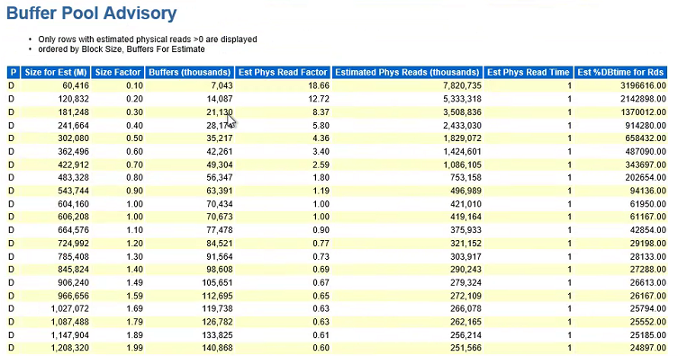

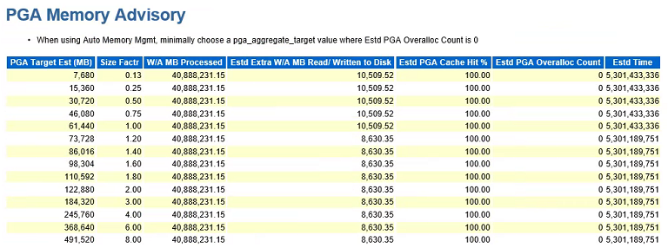
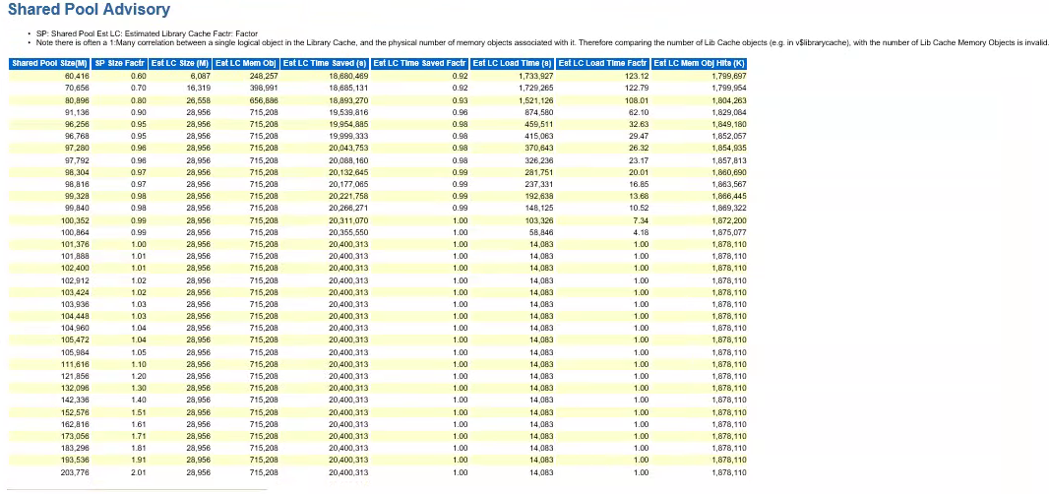
Performance
Hot objects
I/C performance - how much traffic, how many packet drops?

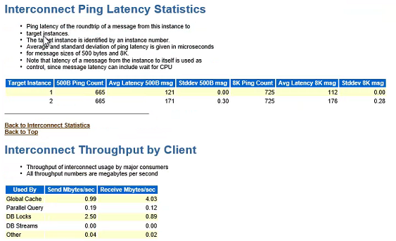
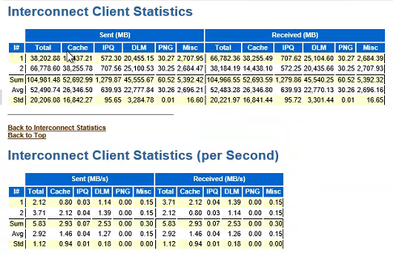

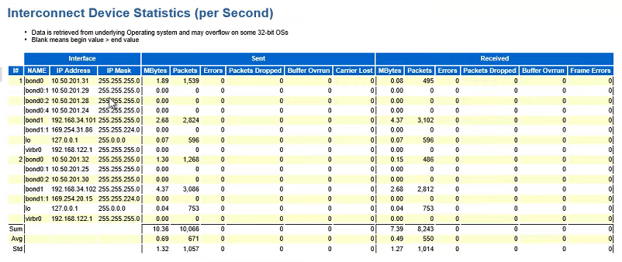

Statistics
- EBS stats are being run via the concurrent program

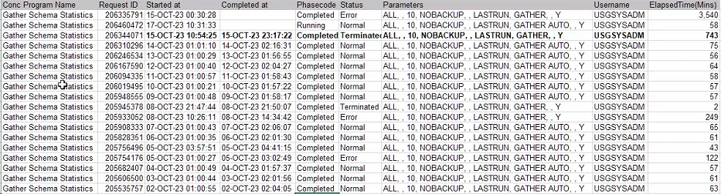

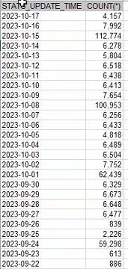

We can see the huge difference that GATHER x GATHER AUTO have.

That happens because:
GATHER — Gathers statistics on all objects in the schema.

GATHER AUTO — Gathers all necessary statistics automatically.
The database implicitly determines which objects need new statistics and determines how to gather those statistics.

I recommend a new layer:

- During week, run with GATHER STALE:
GATHER STALE — Gathers statistics on stale objects by querying the *_TAB_MODIFICATIONS views. Also, the database returns a list of objects found to be stale.

- During weekends, run with GATHER AUTO, except on weekend per month (First weekend after day one);
- At the first weekend after day 1, run GATHER. Note that this will take longer as will GATHER for all tables.

Performance Cases
9 Performance Cases:
00347713 - optimizer_features_enable='11.2.0.4'', this form is from 2006
00348061 - optimizer_features_enable='11.2.0.4''
00348479 - optimizer_features_enable='11.2.0.4''
00350308 - ORA-01652: unable to extend temp segment by 128 in tablespace TEMP/ TEMP has 2.3TB
00351689 – Split in 00352565 and 00352568
00352147 -
00352565 - Increase REDO LOG FILE SIZE
00352568 - degree => 10
00352572 - ORA-01652: unable to extend temp segment by 128 in tablespace TEMP/ TEMP has 2.3TB - 2013 was the last time any developer touched this report
From the cases discussing performance, most actions fall in to replicate the execution plan that was available on 11g. They also share the most affected programs are much older than 19c (2006, 2013).
11g was stable or at least had a known performance, and since 12c several new access paths were added, leading to substantial change on the OPTIMIZER behavior.

PCP vs. Node affinity review required (EBS DBA)

OS Watcher Review
- Data available only for node 1
- Data shared between 10/30 09:00 AM up to 11/01 09:00 AM.

The main points of attention seems to be CPU usage and Load Average.

For CPU, through mpstat, the average cpu usage for all CPUs is under 20%.
But it reach peaks of 50 to 60%, between 09:00 AM and 10:00 AM.

For Load Average, from top collection, we see the average load under 20 But it reach peaks between 60 and 72, between 12:00 AM and 01:00 PM and 05:00 PM and 06:00 PM.

From the other metrics collect, did not see anything indicating problems.
Network metrics seems fine, did not found any evidence of packet loss.

CRS/ASM
ASM Alert.log from node 1 starts at 2021-06-15T01:53:18.
File available ends at 2023-10-17T21:29:29
Generic ORA-29785: GPnP attribute GET failed with error [CLSGPNP_ERR] seen in ASM alert.log, does not seem to be impacting the availability but requires further investigation.
Errors points to Wallet available at /u001/orcl/glbl/product/19.0.0.0/gri/gpnp/lxprdb01/wallets, checked the privileges for the folder and the files on it and are the same from the ones available at node lxprdb02 where we do not see the error.
The error is not solved with a reboot or stop/start of the cluster, once it was done a reboot when the transparent hugepages were performed. Reviewed other logs from cluster 1 as ohasd_orarootagent_root.trc and gpnpd.trc but nothing was tracked for the issue.

The error does not seem to impact the current cluster health as no functionality is failing. Need further review.

Best Practices/Recommendations
No DRM – DONE 10/13/2023
THP – DONE 10/17/2023

Based on the log switch average per day and the optimum log size, the recommendation is:

- Recreate redo with 12 groups of 5G
- Set initial value for LOG_BUFFER = 500MB

Parallel processes are seeing, and they would benefit for an initial value for LARGE_POOL_SIZE, for at least 5% of SGA. As SGA is currently 700G, set LARGE_POOL_SIZE to 35G.

From the oswatcher files available from node 1, we can see huge loads on the intervals below:
09:00 AM to 10:00 AM
12:00 AM to 01:00 PM
05:00 PM to 06:00 PM

Focus the tunning activities on these periods.
One first proposal – set OPTIMIZER_FEATURES_ENABLED=’11.2.0.4’.
The performance on 11g was known and stable. From 12c onwards several new access paths were added, leading to performance issues due to behavior change.
Setting OPTIMIZER_FEATURES_ENABLED would allow the optimizer to behave as 11g while still using all the other features available on 19c.
Use than SPA to gather the main queries from PROD and test them on UAT 19c with OPTIMIZER_FEATURES_ENABLED=’19.7.0.0’.
SPA will produce a report showing which queries will have an execution plan change, for the better or for the worst. Having this would expedite any work over sql_ids.

Add a new layer to GATHER STATS:
- During week, run with GATHER STALE:
GATHER STALE — Gathers statistics on stale objects by querying the *_TAB_MODIFICATIONS views. Also, the database returns a list of objects found to be stale.

- During weekends, run with GATHER AUTO, except on weekend per month (First weekend after day one);
- At the first weekend after day 1, run GATHER. Note that this will take longer as will GATHER for all tables.

On the environment layer, from the cat bond0 and cat bond1 commands, we could see link failures reported.
Review link failures for the nic cards in use for bond0 and bond1.

eRT Case (following was set after upgrade to 19c to fix the performance issues):
alter system set "_optimizer_use_feedback"=FALSE sid='*' scope=spfile;
alter system set "_optim_peek_user_binds"=FALSE sid='*' scope=spfile;
alter system set "optimizer_use_sql_plan_baselines"=TRUE sid='*' scope=spfile;

